Posted 06/27/2022

NOTICE OF PUBLIC HEARING

SC Regional Housing Authority No. 3 (SCRHA#3) will hold a public hearing to discuss its Moving to Work (MTW) Plan and application package for said plan. The public hearing will occur on Wednesday, July 20, 2022, at 3:00 p.m. at the main office of SC Regional Housing Authority No. 3 10938 Ellenton Street Barnwell, SC 29812 (Across from the Barnwell Department of Social Services.
SCRHA#3 is proposing to apply for MTW status via application to The United States Department of Housing and Urban Development (HUD). Interested parties may obtain a copy of the MTW Plan from the Housing Authority’s website at www.scrha3.org or at the Housing Authority’s main office at 10938 Ellenton Street Barnwell, SC 29812. Should you wish to comment on the proposed changes please submit comments in writing to the above address, or via email to Elizabeth Overton at boverton@southeasternhcd.org, by July 25, 2022.

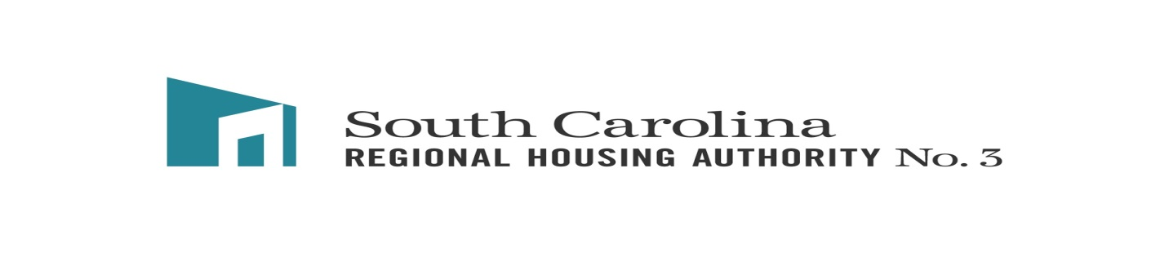
Moving To Work Proposal
Asset Building

Purpose
The purpose of the Moving to Work Proposal is for Section 8 and Section 9 residents to build assets through an opt-out incentivized savings program which is wrapped in supportive services aimed at education, behavior modification and asset creation.
Eligibility
Up to fifty percent of residents will be randomly selected for participation in the program. Once, residents have been notified, they will be given the opportunity to opt of the program. Residents who opt to participate will be enrolled in the 24- month program.
Implementation Plan
A savings account will be created by SC Regional Housing Authority #3 on behalf of the resident. At the end of 24 months the ownership of the savings account will be converted to the participant along with any interest that accrued. If the participant’s lease is terminated, voluntarily or involuntarily, before the 24-month period the participant forfeits any funds other than those personally invested by the participant. (Voluntary Savings)
Deposits will be made to the accounts based upon the following criteria:
Activity | Amount | Rate
Automatic | $10 | Monthly
On-time recertification | $50 | Per Occurrence
Completion of Certified Financial Literacy Class with an emphasis on budgeting and credit | $50 | One- time occurrence
Completion of a pre-homeownership class | $50 | One- time occurrence
Completion of a certified homebuyer education course | $75 | One- time occurrence
Enrollment and active engagement in housing counseling with a certified counselor | $25 | Per Month
Enrollment in ROSS Program and active engagement in program goal obtainment | $25 | Per Month
Enrollment in resident training program and active for a minimum of 6 months | $150 | One- time occurrence
Volunteer for ROSS Community Programming Activities | $20 | Per Event
Passed Housing Inspection | $25 | Per Occurrence
For positive renters, on-time rent payments for 3 months | $25 | One- time occurrence
For positive renters, on-time rent payments for 6 months | $40 | One-time occurrence
For positive renters, on-time rent payments for 9 months | $50 | One- time occurrence
Voluntary savings (minimum of $25/month), consistent deposits for 3 months | 25% of deposits made up to $75 | One- time occurrence
Voluntary savings (minimum of $25/month), consistent deposits for 6 months | 50% of deposits made up to $150 | One- time occurrence
Voluntary savings (minimum of $25/month), consistent deposits for 9 months | 75% of deposits made up to $225 | One- time occurrence

Time frames for on-time rent payments and voluntary savings incentives will run concurrently and not consecutively. For example, to receive the full incentives participants would have to pay on-time rent and/or participate in voluntary savings for 18 months total.
Actively engaged in housing counseling and/or ROSS counseling is defined as maintaining monthly check-ins with case manager and positively moving towards goal attainment. Three consecutive missed appointments or consistent “no response” to attempts to communicate will result in the participant being deemed inactive or no progress towards goal attainment after 4 months.

